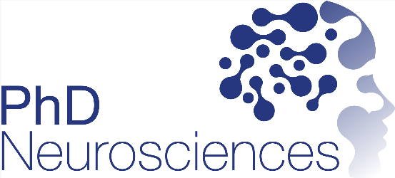

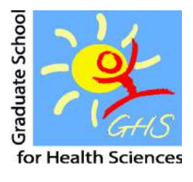



Registration for the PhD Program Neurosciences

1. Personal data
Last name |  |  | First name
Supervisor |  |  | E-mail
Co-Advisor |  |  | E-mail
Mentor |  |  | E-mail
Starting date of PhD studies
Thesis Title
Institute
Office
address
Zip code |  | City
Phone |  | Mobile
E-mail |  |  |  | Matriculation no.
For students of the University of Bern: The PhD Program Neurosciences cooperates with the Graduate School for Cellular and Biomedical Sciences of the University of Bern (GCB) and Graduate School of Health Science (GHS). PhD students in this program benefit from an interdisciplinary education organized by experts in the field. Students enrolled in the PhD program Neurosciences gain 12.5/13 ECTS to graduate from the GCB/GHS and to fulfil the requirements of the PhD program Neurosciences. The certificate of the PhD program Neurosciences will be issued after graduation from the GCB and is valid only in combination with the graduation certificate of the GCB/GHS of the University of Bern.

2. Signatures
PhD Student
- With my signature, I agree on the exchange of personal data between my university / the GCB and the PhD program Neurosciences.
- A short description of the relation of my PhD project to Neurosciences is enclosed (max 500 words).

Place, date |  | Signature

Supervisor and Mentor
Supervisor |  | Mentor
Place, date |  | Place, date

Please send this form to:
UNIBE students: Prof. Dr. Antoine Adamantidis (antoine.adamantidis@unibe.ch), Ass. Prof. Dr. Stéphane Ciocchi (stephane.ciocchi@unibe.ch ) and Thi Bao Trân Vu (tran.vu@unibe.ch )
UNIFR students: Prof. Dr. Gregor Rainer (gregor.rainer@unifr.ch ) and Thi Bao Trân Vu (tran.vu@unibe.ch )

